Future Grid Technologies (Team_9)

LAB University of Applied Sciences
Bachelor of Engineering, Industrial Information Technology
2025
Unubold Luvsandagva

Contents
Section 1. Introduction 1
Section 2. Group Work 1
1. Meeting memo 1
2. Email (to trade fair organizers) 2
Section 3. Individual work 3
1. Flyer 3
2. Sales pitch draft 4
3. Press release 5
Section 4: Commentary & Reflection 6
1. Teamwork Analysis 6
2. Reflection on my own performance 6
3. What I Learned About Professional Communication 7

Section 1. Introduction
This portfolio presents the collaborative and individual works undertaken by our team at “Future Grid” Technologies in preparation for the Trade Fair. The goal of this project was to showcase our innovative product line focused on smart cities, healthcare, and cybersecurity technologies.
Throughout this project, we aimed to develop strong professional communication materials, including a meeting memo, email to trade fair organizers, flyer, sales pitch, and press release. These materials were crafted to promote our company, engage potential investors, and highlight the key features of our cutting-edge products and technology. This portfolio reflects both the teamwork and my individual contributions, offering insights into the process and lessons learned.

Section 2. Group Work
First of everything we talked about what kind of product we are going to make that will help make the world a better place thus Future Grid was born.

Meeting memo
SUBJECT: Product Strategy and Trade Fair Preparation
As we are preparing for the upcoming Trade Fair, our team at Future Grid Technologies has strategized to ensure the success of our product showcases. Each of us is focusing on an innovative solution that aligns with our company’s mission to develop cutting-edge smart city, healthcare, and cybersecurity technologies.
Product Descriptions & Strategy
Our company will present four key products:
- SmartCitySecure – A server-based security solution ensuring real-time encrypted data transfer and AI-powered protection for smart cities.
- Touch Surgery – AI-assisted medical technology that enhances surgical precision and training.
- Safe and Secure – A cybersecurity management system ensuring risk-free remote surgery.
- NextGen-Tech (My part) – 5G-powered hardware for real-time, remote surgery execution.
Goals for the Trade Fair
- Engage with industry professionals and potential investors.
- Demonstrate how our technologies address modern challenges.
- Strengthening our brand presence in smart cities and healthcare innovation.

Email (to trade fair organizers)
Dear Pekka,
We are excited to confirm our participation in the upcoming Trade Fair as The FutureGrid Technologies, a technology-driven company specializing in smart city solutions, healthcare technology, cybersecurity, and, hardware
Our company will be showcasing four innovative products:
- Smart City Secure – A server-based security solution ensuring safe and efficient data transfer in smart cities through real-time encryption and AI-powered protection.
- Touch Surgery – An AI-assisted medical technology that enhances surgical precision and training through data-driven insights and real-time guidance.
- Safe and Secure – A comprehensive cybersecurity management system that is unlike any seen before. With this enhanced security, we can reliably bring forth remote surgery with no conceivable security risks.
  - “Safe and secure” aims to deliver these cutting-edge technologies to commercial customers with the help of professional engineers and world class surgeons.
  - Motto: “Even in regions with limited access to surgeons and hospitals, our technology enables healthcare to reach every corner of the globe, saving millions of lives."
- NextGen-Tech – Cutting-edge hardware for remote surgery, powered by 5G technology, enables surgeons to perform precise operations from anywhere, with ultra-low latency and real-time control.
We have attached our product flyers for your reference. Please let us know if there are any additional steps or materials required for the event. We look forward to showcasing our innovations and engaging with potential partners at the fair!
Best Regards,
Unubold Luvsandagva
Marketing Manager
Unubold.Lu@FutureGrid.com
+358 420694040

Section 3. Individual work

Flyer
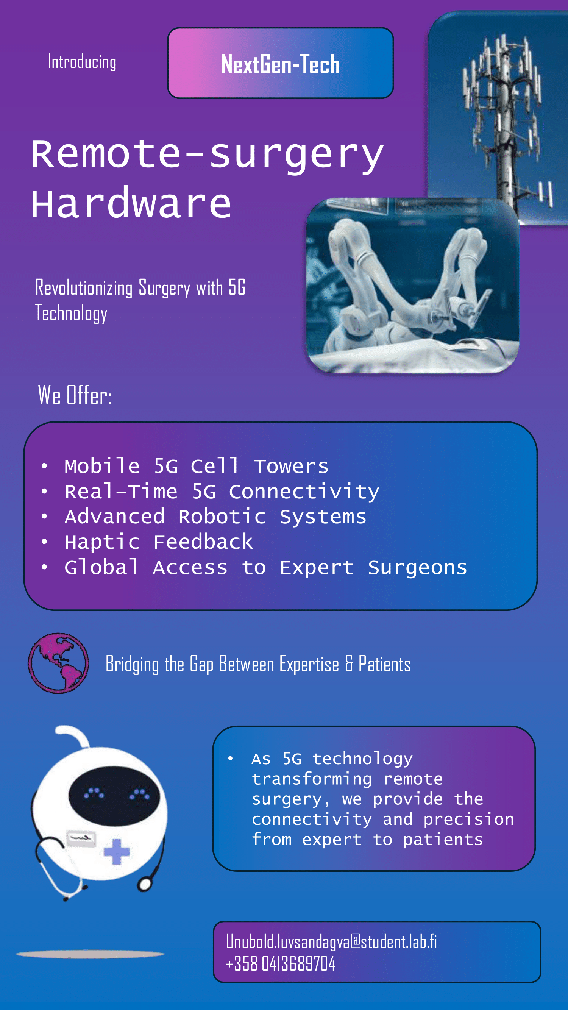

Sales pitch draft
"Imagine a child in a distant village needing life-saving surgery, but there’s no specialist nearby. With NextGen-Tech, distance is no longer a barrier."
Hi, I’m Unubold from Future Grid Technologies, and I’m excited to introduce NextGen-Tech - our groundbreaking 5G-powered remote surgery solution.
Here’s how it works: NextGen-Tech uses ultra-low latency 5G networks to connect expert surgeons with patients in real-time, no matter where they are in the world. It enables complex surgeries to be performed remotely with precision and zero lag, as if the surgeon is right there in the operating room.
But what makes NextGen-Tech truly transformative is its focus on global accessibility. Our mission is to bridge the gap in healthcare by empowering hospitals in underserved and remote regions. This technology allows local medical teams to collaborate with world-class surgeons during critical procedures, saving lives that might otherwise be lost due to distance or lack of expertise.
Join us in bringing expert surgical care to those who need it most.

Press release
Future Grid Technologies Launches NextGen-Tech: Breaking Barriers in Remote Surgery with 5G Connectivity
Lahti, 2025.02.03 – Future Grid Technologies proudly announces the launch of NextGen-Tech, a groundbreaking 5G-powered remote surgery solution that brings expert medical care to patients in even the most remote locations.
"Imagine a child in a distant village needing life-saving surgery, but there’s no specialist nearby. With NextGen-Tech, distance is no longer a barrier," said Unubold, spokesperson for Future Grid Technologies.
NextGen-Tech utilizes ultra-low latency 5G networks to connect expert surgeons with patients in real-time, enabling complex surgeries to be performed remotely with precision and zero lag as if the surgeon is physically present in the operating room.
What truly sets NextGen-Tech apart is its mission to improve global healthcare accessibility. Designed to empower hospitals in underserved and remote regions, this technology allows local medical teams to collaborate with world-class surgeons during critical procedures. By eliminating geographical barriers, NextGen-Tech has the potential to save countless lives that might otherwise be lost due to a lack of specialized medical expertise.
Our goal is to bridge the gap in healthcare and ensure that no patient is left behind due to their location.
Join us in bringing expert surgical care to those who need it most.
Contact:
Unubold
Marketing Manager
Unubold.Lu@FutureGrid.com
+358 420694040

Section 4: Commentary & Reflection

Teamwork Analysis
Our group was able to complete the group work including the meeting memo, email to trade fair organizers, and preparations for the trade fair through a combination of early planning, clear role distribution, and open communication. We started by identifying a common thread that connected us all: our previous assignment focused on 5G technologies. This shared experience made it easier for us to brainstorm and agree on a company concept centered around 5G-driven healthcare solutions, a field we felt was both meaningful and in high demand.
To manage the group tasks effectively, we divided responsibilities based on the key components required for our company:
- 5G Hardware for Remote Surgery (my focus)
- Security Systems
- Data Transfer Solutions
- Software Development
This clear role assignment helped us stay organized and allowed each member to focus on a specific part of the company. We have scheduled regular meetings to ensure alignment and used shared documents to keep everyone updated on progress.
How well did our group work together?
Overall, our group collaborated well. Everyone was active and engaged, contributing ideas and completing their assigned tasks on time. Open discussions helped us resolve any issues and ensured that all parts of the project fit together cohesively.

Reflection on my own performance
How well did I manage the individual exercises?
I managed my time effectively and completed all the materials by the set deadlines. The flyer was visually engaging and focused on the core benefits of NextGen-Tech. The sales pitch was straight to the point, emphasizing the product’s impact on global healthcare accessibility. The press release followed a formal structure and highlighted our company’s participation in the trade fair while showcasing NextGen-Tech’s innovative features.

Was I an active team member?
I am sure I was an active and reliable team member. I participated in team discussions, contributed ideas during brainstorming sessions, and ensured that my individual work aligned with our overall company vision while following deadlines.
What kind of skills did I bring to the team?
- Brainstorming session: Sharing ideas with team members
- Organizational Skills: I managed my tasks efficiently, helping the team to keep the project on schedule.
What would I do differently now?
If I could redo this project, I would focus on improving team communication even further. Although our meetings were productive, more frequent check-ins might have helped us align our old and even new ideas even more closely.

What I Learned About Professional Communication
This project reinforced the importance of clear, audience-focused communication in a professional setting. I learned how different types of communication, whether a memo, sales pitch, or press release serve unique purposes and require well prepared approaches. Crafting these materials taught me to consider the audience’s needs, whether it was trade fair organizers, potential investors, or the general public.
Additionally, I learned how vital internal communication is when working in a team. Open dialogue, regular updates, and clear role assignments were key to our success.

